University of Melbourne Student Union
Meeting of the People of Colour
Agenda
15/07/2022
Meeting 12(22)
Location: Zoom

- Procedural Matters
  - Election of Chair
Motion 1: That Moe be elected as Chair
Mover: Moe Seconded: -
CARRIED/FAILED
  - Acknowledgement of Indigenous Custodians
Acknowledged
  - Attendance
Moe, Hiba, Reham, Lynne, Disha, Nishank, Isi
  - Apologies
  - Proxies
Wasif proxied to Disha
Anushka proxied to Lynne
Moosa proxied to Nishank
  - Membership
  - Adoption of Agenda
Passed Motion: To adopt the agenda as presented.
Mover: Moe Seconded: Reham
CARRIED/FAILED

- Confirmation of Previous Minutes
Attached with the email - Minutes 13(22)
Motion: To accept the previous minutes as a true and accurate record of meeting 12(22) on 15th of July.
Mover: Moe Seconded: Disha
CARRIED/FAILED

- Conflicts of Interest Declaration
- Matters Arising from the Minutes
- Correspondence
- Office Bearer Reports
Moe spoke on their OB reports.
Motion: To accept the Office Bearer Reports en Bloc
Mover: Disha Seconded: Nishank
CARRIED/FAILED

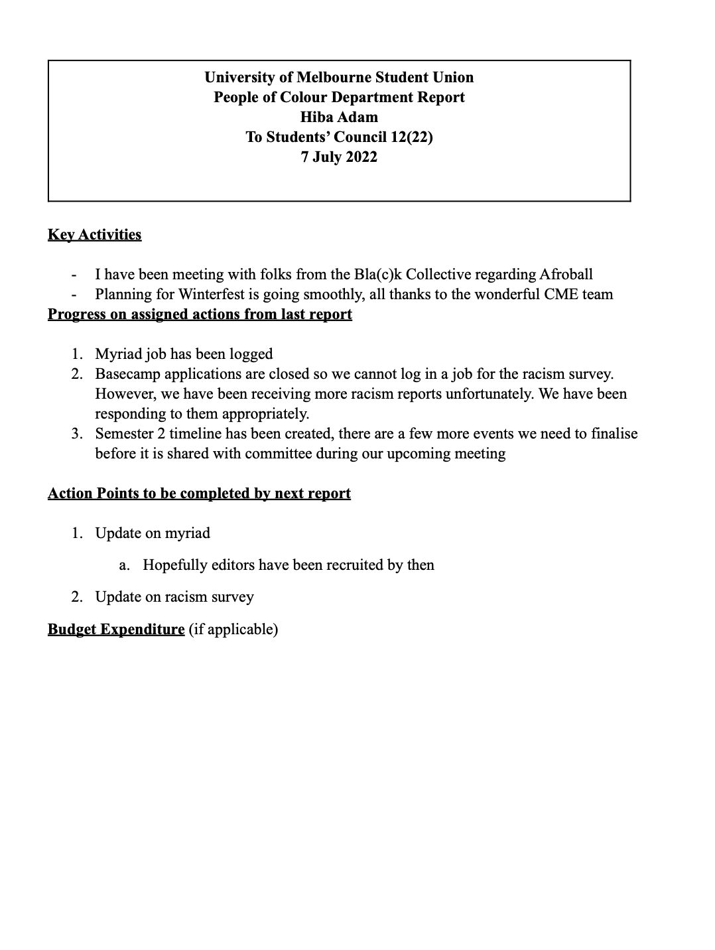

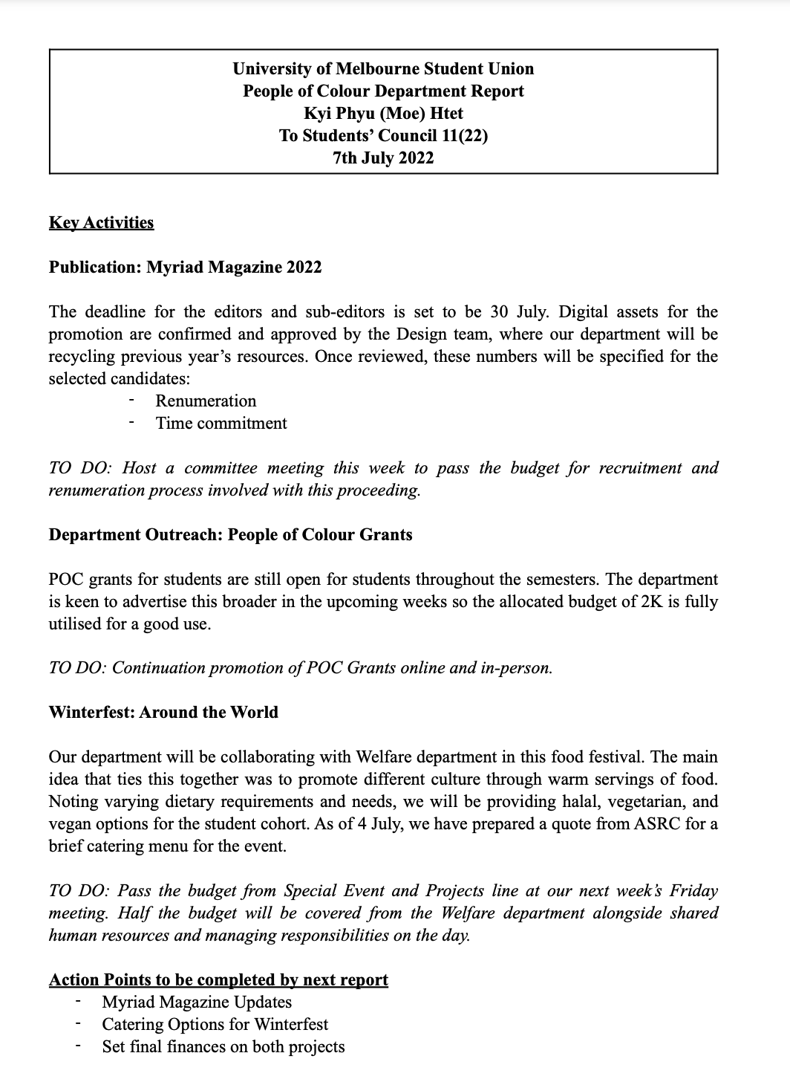

- Motions on Notice
- Motions without Notice
- Other Business
- Next Meeting
- Close
11:23AM

