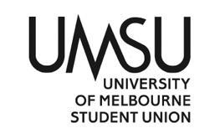
University of Melbourne Student Union
Meeting of the Welfare Committee
Agenda
1 pm Thursday 22nd April
Meeting [5](21)
Location: Zoom

- Procedural Matters
  - Election of Chair
Allen moves to elect himself as chair
Seconded by Thomas
CWD

  - Acknowledgement of Indigenous Owners

So acknowledged
  - Attendance
Allen, Caroline, Harry, Jordan, Sophie, Thomas
  - Apologies

Yashna, Zahra
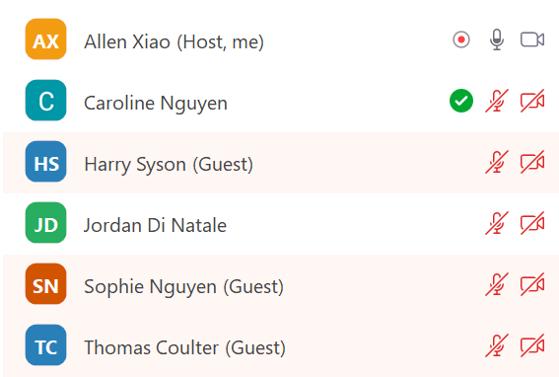
  - Proxies
Yashna proxies to Caroline
  - Membership
  - Adoption of Agenda
Allen moves that the agenda be adopted
Seconded by Thomas
CWD
- Conflict of Interest Declarations
- Matters Arising from the Minutes
- Correspondence
- Office Bearer Report
Allen speaks to both his and Hue Man’s reports.
Allen: due to the intensive activity in the Department in the past few weeks, there are over 15 pages of reports submitted to Council. As such, they have not been included in the Agenda for accessibility.
Motion: to accept the Office Bearer Reports
Moved by Jordan
Seconded by Thomas
CWD
- Other Reports
- Motions on Notice
- Motions Without Notice
8.1 Supplies for Southbank
8.2 Restocking Union Mart
- Other Business
- Next Meeting
- Close

Welfare
Allen Xiao

Next comes Autumn, no longer with the hot blood of youth... - Ovid, Metamorphoses XV
It’s hard to believe we’re only a month into uni. By the time you read this report, we will have finished the Easter holiday, started the mid-sem break, and (hopefully) completed some assignments. While Daylight Savings might be over and the days shorter, our work continues- in the warmth of our fully-stocked office space no less!

Key Activities
The Welfare Office is now refurbished with food, supplies, and the beginnings of Union Mart, the UMSU Resource Hub. Come visit us when you’re free and grab an Up & Go (or a kombucha for the more health-conscious). Check out Hue Man’s report for a detailed breakdown on what you can get at the office- there is, as we promised in our pitch video earlier this year, a tonne of free food.
On the 25th of March, I spoke at the ‘Defend our Education’ Rally hosted by UMSU x NUS Education on behalf of the Welfare Department. Despite the Commencement Ceremony blaring music at us nearby, it was a privilege hearing some truly powerful speakers from UMSU and the NTEU. Advocacy at a national level is a powerful weapon against one of the most neoliberal administrations in recent memory; we are always keen to extend our collaboration with the NUS whenever possible.
On the 31st of March, I met with A/Prof Gyorgy Scrinis, lead researcher at the Talking Hunger project at Unimelb. The project was launched last year to tackle food insecurity on campus, and has published preliminary reports on the impact of inadequate food provision. It aims to create a university-wide food security policy with the input of student representatives, particularly as the transition to the NSP is being finalised. In particular, Gyorgy hoped that the university could subsidise healthy meals (e.g. fresh fruit and vegetables) on campus, which aligned excellently with Welfare’s key priorities in 2021.
It is disappointing that the University has ignored such basic demands. I recommend Councillors check out the Talking Hunger podcast (https://socialequity.unimelb.edu.au/projects/talking-hunger-understanding-food-insecurity-on-campus ), as well as its associated research on The Conversation. We are very keen to follow up with Gyorgy and his team, and are exploring advocacy ideas that involve action from the broader student body.

Welfare Collective is a work in progress, and we are slowly confirming an agenda for the coming semester. The Collective is a flexible time for a range of activities, from campaign planning to volunteering to pre-exam group study- we also welcome your input for workshops to run during this time.
A massive shoutout to Comms, who have done excellent work in creating a set of posters for online release! While the Collective is anticipated to be mostly online, we hope to facilitate a transition to in-person events (ft. snacks if all goes to plan) as soon as possible. Watch this space for more updates post-midsem break.
Finally, although scientific calculators might seem a rather incongruous addition, we are very excited to announce that the UMSU Info Desk have agreed to loan out our supply! We’re working to confirm final details, and can’t wait to help some STEM students in a pinch (I know I would have loved this when I was struggling through first-year maths and chem…)

Progress on assigned actions from last report
1. Finalise website with updated events, especially as we receive additional confirmation on event feasibility from Comms. Still ongoing- although there should be more clarity as soon as the Welfare Collective schedule is confirmed.
2. Run Committee meeting with Hue Man. Convened on the 30th of March. We were proud to approve payment for the last items for the Resource Hub, including a set of kitchen appliances for hire.
3. Refurbish Welfare Office and set up new office space. Completed (?!) First floor Union House, right side of the big corridor. Do come and visit when you’re free- if you want your daily dose of 80s C-pop greatest hits, you’ve come to the right place.
4. Distribute Pocket Guides! Distributed. You can see the sheepish grin of our new mascot all around campus- they still need a name though, any suggestions?
Action Points to be completed by next report
1. Organise Welfare Collective as soon as practicable after the mid-sem break.
2. Run Committee meeting with Hue Man.
3. Continue discussions with University-based stakeholders
4. Meet with representatives from SSDP.

- Motions Without Notice
  - Supplies for Southbank

Preamble: Southbank students in need are often unable to access the resources provided by UMSU on the Parkville campus. We hope to address this by approving purchase of additional Union Mart supplies to be distributed to Southbank students.
Motion: to pass up to $500 from the budget line ‘Regular Projects’ for the purchase of food, daily necessities, and additional supplies for Southbank students.

Moved by Caroline
Seconded by Thomas
CWD
  - Restocking Union Mart

Preamble: Having seen increased usage in the past few weeks, Union Mart is in need of some restocking before the end of semester. These purchases are aimed at maximising the impact of UMSU Welfare’s services as the semester progresses.
Motion: to pass up to $1000 from the budget line ‘Regular Projects’ for the purchase of food, daily necessities, and additional supplies for Union Mart.

Jordan: What’s the difference between Union Mart and the Resource Hub?
Allen: Union Mart is the renamed, official version of the Resource Hub. Previous Office Bearers did not have a permanent, extensive space dedicated to these resources. We will be publicising this over the coming weeks!

Moved by Thomas
Seconded Jordan
CWD

10. Next Meeting
- Close

