

**University of Melbourne Student Union**

**Meeting of the Education Committee**

**Minutes**

**(Friday, 21st of April, 2023, 13:00)**

**Meeting 7(23)**

**Location: Room 202 Building 168**

Room 202, Level 2, Building 168

https://unimelb.zoom.us/j/83449672043?pwd=YkJyaVdOZnNpcE81SjFvcnB0VU00UT09

**Password**: education

**Meeting opened at 13:04**

1. **Procedural Matters**
   1. Election of Chair

Motion 1.1.1: That Mary be elected as Chair

Mover: Mary

CARRIED

* 1. Acknowledgement of Indigenous Custodians

So acknowledged.

* 1. Attendance

Carlos Lagos Martin, Mary Kin Chan, Taj Takahashi, Rahul Mittal, Anita Keng, Lachie Mutimer, Divya Rajagopalan, Tom Xie.

* 1. Apologies

None.

* 1. Proxies

None.

* 1. Membership

No changes to membership since last meeting.

* 1. Adoption of Agenda

Motion 1.7.1: To adopt the agenda as presented.

Mover: Mary

CARRIED

1. **Confirmation of Previous Minutes**

**2.1** Minutes 6(23)

Motion 2.1: To accept the previous minutes as a true and accurate record of meeting 6(23).

Mover: Mary Seconded: Divya

CARRIED

1. **Conflicts of Interest Declaration**

None declared.

1. **Matters Arising from the Minutes**

None.

1. **Correspondence**

None.

1. **Office Bearer Reports**

Carlos:

Carlos reported on the Education department’s recent submission to the Universities accord after having summarised and finalising the discussions from the USMU Assemblies.

Carlos implored the education committte to come along to the banner painting for the NTEU’s student solidarity campaign and reported on all the details surrounding Education Public’s participation in the industrial action.

Mary:

Mary reported on developments for Melbourne University and the wider tertiary education sector addressing the potential use of AI in course work and how it relates to Education Academic. Mary reported on the way that Melbourne University might investigate artificial intelligence use in the context of academic integrity and how the university handles student misconduct hearings when the use of artificial intelligence in assessments is suspected.

Taj:

Taj also recounted a meeting with Advocacy and Legal earlier on the day but otherwise reported similarly to Calors and Mary.

Motion 6.1: To accept the Office Bearer Reports en bloc

Mover: Mary Seconded: Divya

CARRIED

1. **Other Reports**
2. **Operational Business (Motions on Notice)**
3. **General Business (Motions on Notice)** 
   1. **Financial update**

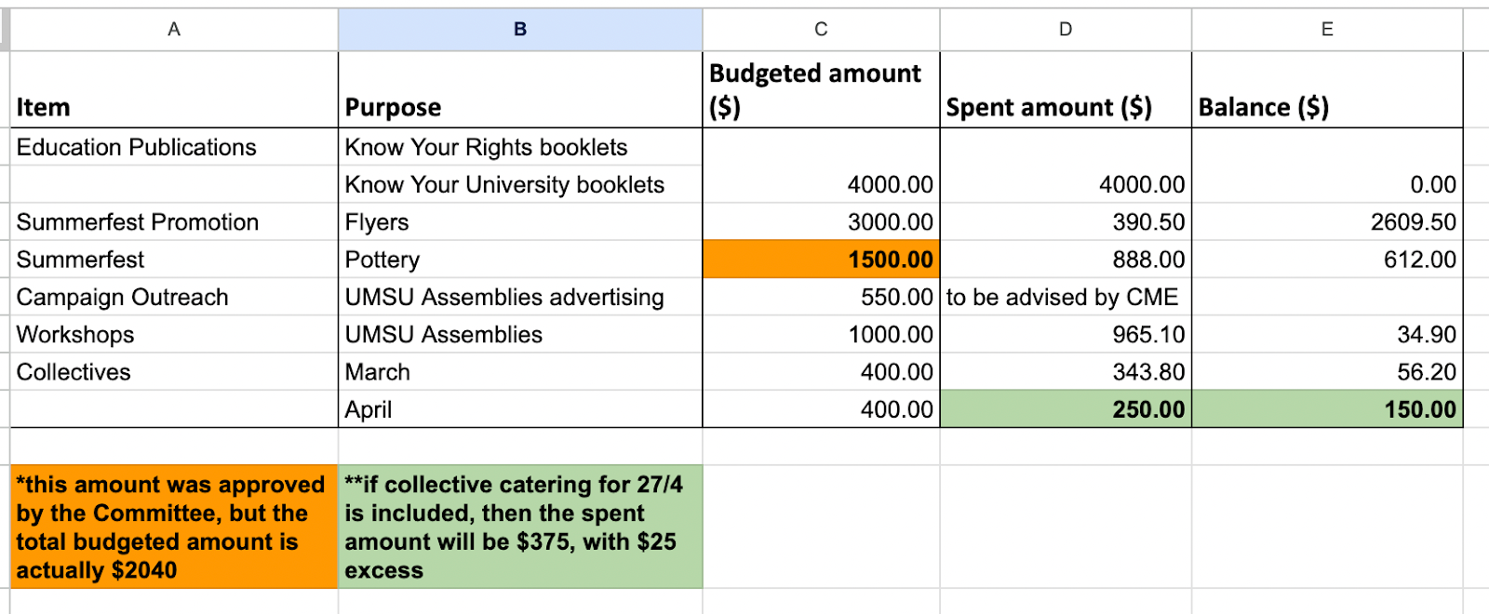

Motion 9.1: Members to note the financial update.

Mover: Mary Seconded: Divya

CARRIED

**9.2. NTEU industrial action student solidarity**

Motion 9.2: Members to note the financial update.

To approve spending $1000 within Tag “Access and Inclusion” under account number 03-60-620-3839 “Programs”.

The allocated budget was set up to cover the cost of workshops and catering for workshops in Semester 1. This will mean that we will have spent the allocated budget for this specific Tag (i.e. $0 remaining). The purpose of this spending is to cover the costs of banner painting, including the cost of fabric and painting materials.

Mover: Rahul Seconded: Divya

CARRIED

**Tom enters the meeting at 1:30 during motion 9.3.**

**9.3. End of sem BBQ**

Motion 9.3: To approve spending $1925 within Tag “Food & Beverages” under account number 03-60-620-3840 “Events”.

The requested amount was calculated using the UMSU event calculator. BBQs are integral to the department as they are spaces where we can promote campaigns, reach out to students and provide social activities for the cohort. The BBQ will include 150 bread and sausages (accounting for dietary requirements), non-alcoholic beverages, and infrastructure like marquees and bins. We hope to host approximately 75 students accounting for 2 sausages per attendee for a 2 hour period. The education department hopes that through engagement with students in a physical social setting that ‘brand recognition’ of the education

Mover: Tom Seconded: Lachie

CARRIED

**9.4. Catering for collectives**

Motion 9.4: To approve spending $400 for May’s collective catering, within Tag “Collectives” under account number 03-60-620-3839 “Programs”.

Purpose of this spending is to provide catering for collectives for May - approximately 100 dollars per session as specified in the budget proposal. If approved and spent, this means that we will have 1600-400=$1200 remaining for Collectives.

Mover: Lachie Seconded: Divya

CARRIED

1. **Other Business (Motions without Notice)**
2. **Next Meeting**

Friday 5 May 2023, 1:30pm

1. **Close**

**Meeting closed at 1:40.**