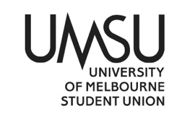
University of Melbourne Student Union

Agenda of the Environments Committee

Meeting 1(21)

Agenda

1.39PM on 17th of December 2020

Location: Zoom (link)
Password: 007445
Agenda
- Procedural Matters
  - Election of Chair
Motion: to elect James as Chair
Mover: James
Seconder: Vishal
CWD
1.2 Acknowledgement of Indigenous Owners
So acknowledged.
  - Attendance
Vishal, Harry, Laura, Jeremy
  - Apologies
Aashi Agarwal, Jaslyn Potter, Rubina Smith
  - Proxies
  - Membership
  - Adoption of Agenda
Motion: to adopt the agenda
Mover: Ann
Seconder: Vishal
CWD
- Confirmation of Previous Minutes
No previous minutes to confirm.
- Conflict of Interest Declarations
- Matters Arising from the Minutes
No previous minutes to confirm
- Correspondence
To work with UMSU Indigenous to release a statement of solidarity with Warriors of Aboriginal Resistance, the Djab Wurrung Embassy and other Indigenous activists fighting for their land.
Xavier had to leave before his Motion could be passed, so his motion had to be postponed to January. However it is very important for UMSU and UMSU Enviro to acknowledge and stand in solidarity with Indigenous activists and their fight to protect their land. Ann and James will be in contact with Brittney from Indigenous Comm next week.
- Office Bearers’ Reports
James’ verbal report: UMSU Declaration of Climate Emergency, Sem 1 planning, budget, spending 2020’s remaining budget on reusable sanitary products for people who menstruate and people who choose to shave.
Ann’s report (attached): TLDR; working on publishing an UMSU declaration of Climate Emergency & writing up a sustainability strategy to propose to UMSU execs (still in the progress of doing research). Did a rough budget plan for 2021, will run committee through budget in January.
Will talk to Uni’s sustainability team to discuss possibilities of declaring a Climate Emergency for the university, hopefully using this to platform divestment and to push for more sustainable changes (this was Rubina and Nandini’s idea! Actual legends). We hope to get your inputs on what you want to see from both UMSU and the university. Send a message in the group chat or through our emails if anything comes to mind!
I’m super excited to work with everyone and to hear everyone’s ideas! Let us know if you want to host a collective, if you had an event idea or if there’s a certain aspect of environmentalism you want us to head in!

Motion: To accept the Office Bearer’s reports
Mover: James
CWD

- Introduction to Committee and UMSU Governance
What are the constitutional requirements of you as Committee members and us as Enviro Officers?
-To attend the meetings
-If a committee member misses 3 scheduled meetings, then they are removed and replaced by the electoral tribunal, generally with a person from their ticket

How does Committee fit into UMSU as a whole?
- The committee is able to pass expenditure from the council-approved budget and set policy for the department
- Get involved! Come to collective, events, campaign meetings, or just drop in at the office for a chat. Being present at meetings is the bare minimum - we can do so much more.
- Motions on Notice
- Other Business
9.1. Brainstorming Collective ideas
Ann’s preliminary ideas:
- Fun/activity based collectives: keepcup decorating, reusable beeswax wrap making, banner painting for protests, cooking and baking together
- Educational collectives: ethics of capitalism, Indigeneity and environmentalism, sustainability on campus, reading group

Vishal’s ideas:
- Seed bank!! – bring seed home, grow seed, when you’re done – bring back seeds when done
- Compost by students – for students: provide students with composting materials

Laura’s ideas:
- Low-tox living collective, low-tox guides to living and in the uni – interested in hosting a collective about low-tox, sustainable transitions to household products.

9.2. Summerfest plans
- With COVID restrictions, everything is still up in the air. If we were to have a physical stall, we’d want to make it seem approachable and welcoming, with banners, decorations, freebies, educational materials, free food – all of this must be done with sustainability kept in mind. We also want our online stall to be approachable and will be working on this over summer.
- Other ideas: having plants, music and educational/sustainable guides about the uni. Will discuss more when plans are more concrete next year.

- Next Meeting
TBC – when2meet will be sent out.
- Close
The meeting was closed at 2.01PM

NOTE: Petitioned meeting
As the meeting started 39 minutes after scheduled time, it cannot be declared valid as a regular committee meeting. Thus, the meeting is a petition meeting, as petitioned by the attending committee members (see attached signatures).
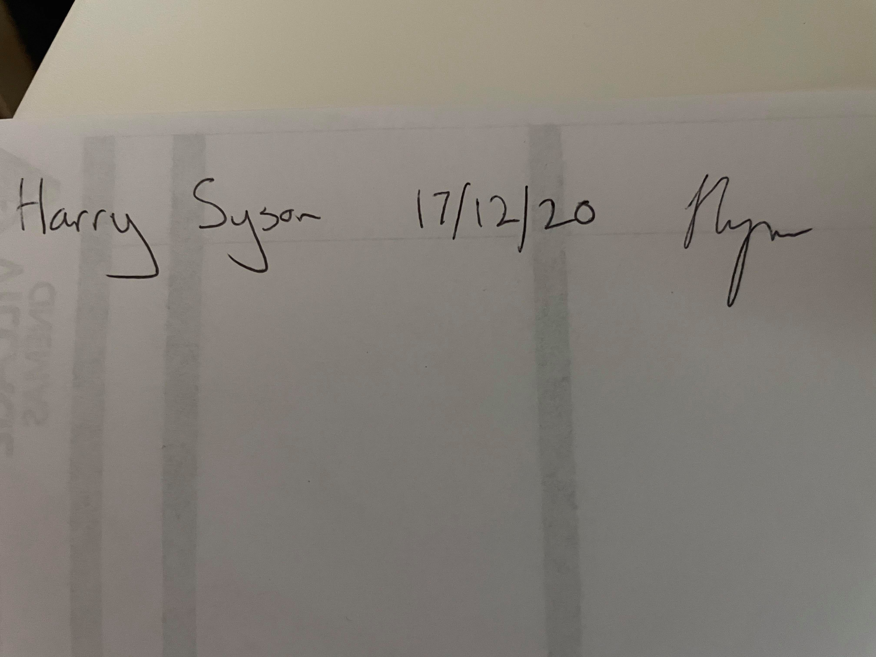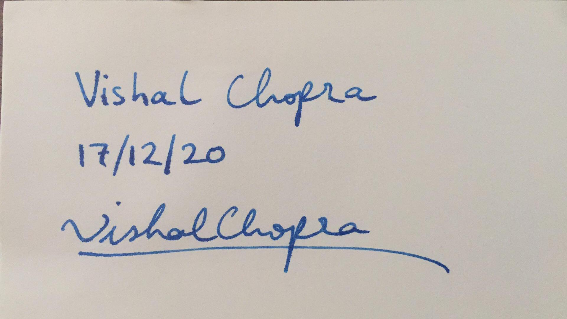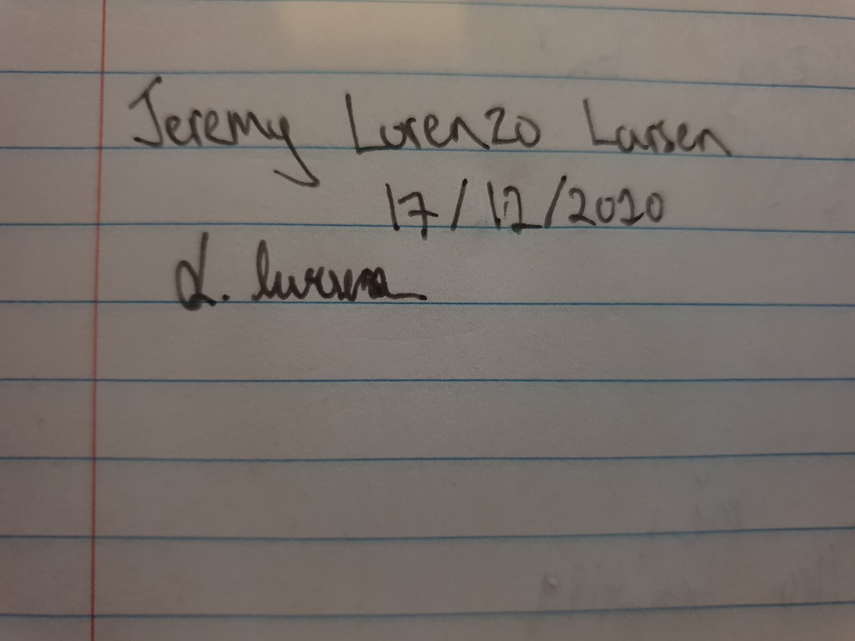

University of Melbourne Student Union
Environments Department Report
Ann Nguyen
To Students’ Council 1(21)
11/12/2020

Key Activities

UMSU to declare a climate emergency (followed by the University of Melbourne)
You can read all about this in our preamble (preamble and motions attached below)! If you’ve read it - thank you so much for your patience. It was a lengthy one.

Our planet is in a state of emergency, and we ask that UMSU use its platform to recognise this existential risk and to take immediate, effective and consistent action in 2021 and in many years to come.

Part of this ‘action’ is to demand genuine commitments to sustainability from the University of Melbourne. This has been an age-old fight between the Union and the University (thank you to the heroes that are past years’ OBs), and it has not been an easy one. We hope that the declaration of a Climate Emergency by UMSU sets precedence for the University, and that it further demonstrates the extent of concern that students have over climate change and the detriment that follows.

Planning for Semester 2
We’ve been working through the handover documents, reading meeting minutes from previous years, contacting the Sustainability Team and previous OBs and committee members to learn from past years’ experiences, and to put those lessons into next year’s events.

Hosting events next year, after the damage that 2020 has created is going to be a confusing time for all of us. We’ve been looking into ways to engage as many people with environmental action as possible, extending the scale of our outreach to include all and to show people (online and offline) that they are supported by a community, regardless of where they are in the world or how involved they’ve been with environmentalism.

With the aim of increasing accessibility to environmental activism, here are some events and strategies we are working on:
- Increasing social media presence
- Increase cross-department, cross-club and cross-faculty collaborations
- Work with UoM’s Sustainability Department and other sustainability stakeholders to ensure internal operations of the University are as sustainable as advertised to students, and that there is a well-funded, consistent effort being made
- And of course, continuing on last years’ legacy: Bike Co-op, demanding divestment, Enviro Week and more!

Action Points to be completed by next report

- To look for key contacts in Melbourne Uni to discuss a declaration of a Climate Emergency by the University.
- To facilitate a committee meeting and develop themes for Enviro Collectives in 2021.
- To have a complete social media, events and engagement strategy for 2021.

Budget Expenditure

No expenditure from the 2020 budget to date.

University of Melbourne Student Union
Environments Department
Motions on Notice
To Students’ Council 1(21)
11/12/2020

Preamble:
One of the foremost existential threats to human animals, non-human animals and our habitat in the modern age is climate change, as continued greenhouse gas emissions and ecological collapse of the same trajectory as today’s will lead to the failure of our planet within the next decade.
We are running out of time to reduce our emissions and protect our future.
In 2020 alone, we experienced a bushfire crisis, atmospheric CO2 reached its record-high, and the Great Barrier Reef saw its most widespread bleaching event. While Traditional Owners of the land work to protect and preserve their land, corporations and world leaders continue to put profit over people, with (so-called) Australia’s government recently announcing a ‘gas-fired recovery’ for our economy, which involves the mining and fracking of five new gas basins on Indigenous lands.
Climate change consists of many overlapping oppressive systems, all of which disproportionately affects people of colour, Indigenous communities and poorer populations. Last September’s Climate Strike, the largest ever in world history, has shown that our generation is well-aware of the damage that climate change causes, and that we are willing to take action against the powerful, oppressive systems that intensify this destruction.
In a world of worsening climate and reinforced oppression, led by ignorant corporations and institutions, we ask that UMSU uses its platform to acknowledge the urgency and severity of the climate crisis by declaring a Climate Emergency and taking immediate steps to further its commitments to sustainability.
What will a Climate Emergency declaration do?
- Increase union-wide awareness of the climate crisis and support students’ participation in climate action:
By making the urgency of the climate crisis clear, the declaration would help mobilise the students to take increasingly meaningful contributions towards the preservation of our planet. While it is unreasonable to expect everyone to instantly transform into an enthusiastic activist, declaring a climate emergency would define UMSU’s role in transforming the zeitgeist of the student population to that of environmental responsibility.
Oftentimes, the threat that climate change poses to individuals, families and communities is intangible. Climate change’s abstract nature makes it difficult to mobilise long-term support outside of dedicated circles of activists. An official declaration of climate emergency from UMSU would build a union-wide awareness that immediate action is required and create a space where climate action is normalised and therefore more accessible.
- Act as a call for action to the University, from its students:
The current “business-as-usual” mindset among government leaders and executives of the University, now accompanied by greenwashed sustainability plans is detrimental to our fight against climate change. A declaration of climate emergency by UMSU would serve as a call to action for the University to see that the business practices of its partners are woefully unsustainable. Raising awareness of this issue to the student populace would be key in distancing the university from destructive, unethical corporations.
Students from all backgrounds come to UMSU to build a foundation to better represent the wishes of the student body. It is this fundamental belief that we can positively impact our peers that serves as the basis for every action that we take as a union.
Actions:
- UMSU acknowledges the urgency of the climate crisis by declaring a Climate Emergency.
- UMSU demands full divestment from fossil fuel industries, more transparency and more climate action from the University of Melbourne.
- UMSU re-evaluates the sustainability of UMSU events and forms a union-wide strategy to lessen climate impact through reducing single-use waste and carbon footprint.
- UMSU and the Enviro Department work with all departments to provide resources to support them in the transition towards having more sustainable operations.
Motion: For the above actions to be moved.

