
University of Melbourne Student Union
Meeting of the [Environment Committee]
Minutes
Friday 19th December 4pm on zoom
Meeting 1(26)
Location: Hybrid – Zoom and in Person @ Unimelb, BLDG 168, LVL 3 outside the Environment Office

https://unimelb.zoom.us/j/81768270270?pwd=DVg2BKqdR7Rbsc9AMmNlTc8BMtaHHP.1
Password: 919767
- Procedural Matters
Bella opened the meeting at 4:02pm
  - Election of Chair
Bella moved to elect herself as chair
Joseph seconded
Motion CWD
  - Acknowledgement of Indigenous Custodians
Always was, always will be.
  - Attendance
Present: Bella, Pippa, Joseph, Chu, Rishika
Not present: Kay, David, Hemang, Emma
  - Apologies
No apologies
  - Proxies
No apologies
  - Membership
No changes to membership
  - Adoption of Agenda
Bella moved to adopt the agenda
Pippa seconded
Motion CWD
- Confirmation of Previous Minutes
NA
- Conflicts of Interest Declaration
No conflicts noted.
- Matters Arising from the Minutes
NA
- Correspondence
No correspondence noted.
- Office Bearer Reports

Bella Beiraghi – Environment Officer Report
Key Activities
We just had budget council, an intense but productive meeting where we secured a $25,000 budget for the Environment Office. This was less than what Kay and I had drafted a budget proposal for, but we will make it work.

Kay and I are both passionate about climate justice and take an intersectional, anti-colonial and anti-capitalist approach to the Department. Climate justice is inextricable from the myriad problems capitalism creates – the for-profit system enables fossil fuel giants and weapons companies to make mega profits from the destruction of people and planet. Our universities are complicit in this – Unimelb has millions of dollars in investments in coal and gas companies, as well as weapons research and even manufacturing.

I want our Department to be loudly campaigning on these issues – I have plans for a Palestine solidarity week at the beginning of semester, to be co-hosted by Students for Palestine. I also think we should have regular environment collective meetings in collaboration with other clubs and societies to discuss and plan how to use our Department to build climate & social justice campaigns on campus.

I’m very excited to work with everyone on the committee to make that happen! If you have any ideas please bring them to committee meetings, or feel free to message me anytime.

Summary of actions and achievements since last report:
Budget council done!

Monies approved for expenditure since last report:
NA
Expenditure made since last report:
NA

Bella moved to accept the Office Bearer reports
Pippa seconded
Motion CWD

7. Motions on Notice
7.1: to approve the Environment Department Budget for 2026, allocated into the following budget lines:
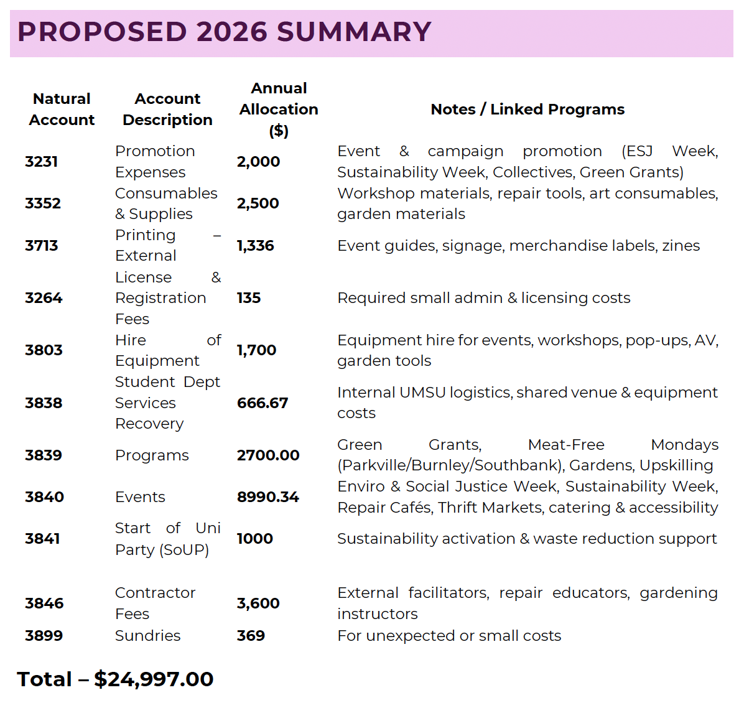
Moved: Pippa Jackson
Seconded: Bella Beiraghi
Motion CWD

- Other Business (Motions without Notice)
No motions without notice.
- Next Meeting
In January – TBC!
- Close
Bella closed this meeting at 4:45pm

