
University of Melbourne Student Union
Meeting of the Welfare Committee
Agenda
(Friday, 16 May 2025, 6:30pm AEDT)
Meeting 7 (25)
Location: Zoom/Meeting Room 201, Building 168

https://unimelb.zoom.us/j/83245706539?pwd=ehJx6dbCoRk6Jl6VucdbRF1KRN0H0a.1
Password: 929176
- Procedural Matters
Meeting Open at 6.38pm
  - Election of Chair
Motion: That Kunal Dewani be elected Chair

Mover: Kunal Dewani Seconder: Vinayak Kapoor

Carried with Dissent
  - Acknowledgement of Indigenous Custodians
Acknowledging the Traditional Owners of the land on which we work, live and learn. We pay our respects to their elders past, present and emerging, and acknowledge this land was stolen and sovereignty was never ceded.
  - Attendance
Raechel, Vinayak, Meet, Cynthia, Emily as committee
Joshua, Sonika, Abhie, Elton, Leon, Shivam as observers
  - Apologies
none
  - Proxies
none
  - Membership
No membership changes.
  - Adoption of Agenda

Motion: That the Agenda as presented be adopted.

Mover: Kunal Dewani

Carried without Dissent
- Matters Arising from the Minutes
- Confirmation of Previous Minutes
Motion: That the Committee accept the Minutes of Meeting 6(25) of the Welfare Committee as true and accurate.
Mover: Kunal Dewani
Carried without Dissent
- Conflicts of Interest Declaration
- Correspondence
- Office Bearer Reports
  - Filia Cahyadi
As attached and circulated
  - Kunal Dewani
    - Key Activities

    - Summary of actions and achievements since last report:

- Ran Union Mart very week, including Week 6, Mid-semester break, Week 7, Week 8 and Week 9. We are proud to state that Union Mart was one of the few grocery stores across Australia to be open on Good Friday and ANZAC Day. I have attached the data of how many students attended throughout the weeks. The fact that so many students showed up to Union Mart during the Mid-Semester Break, even when the entire campus was dead, shows how the students are affected by the Cost-of-Living Crisis and Food Security, and how important it is for us to keep working.

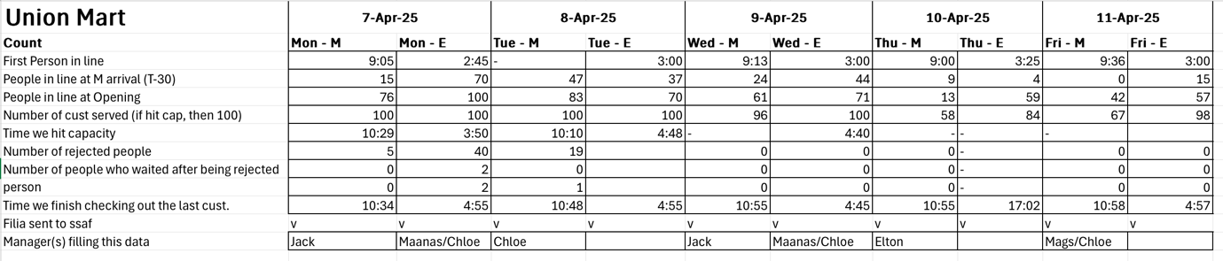
Figure 1: Week 6 Data for Union Mart
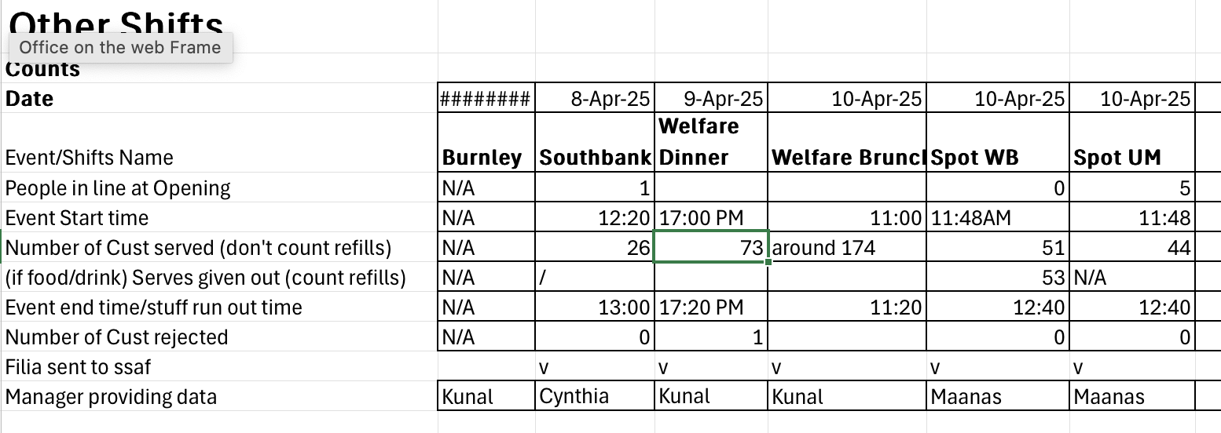
Figure 2: Week 6 Data for other UMSU Welfare Programmes
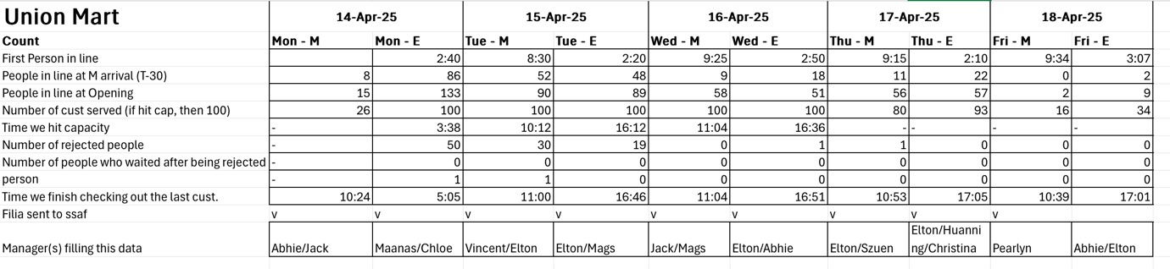
Figure 3: Week 7 Data for Union Mart
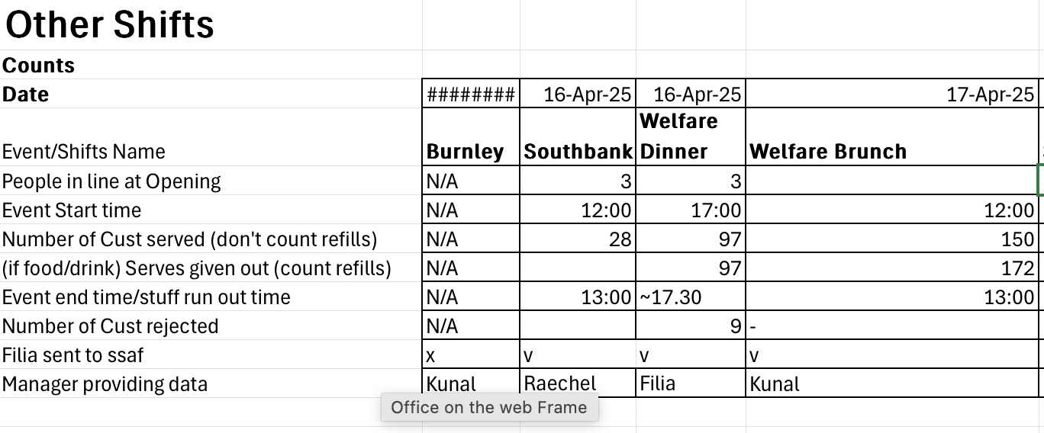
Figure 4: Week 7 Data for other UMSU Welfare Programme
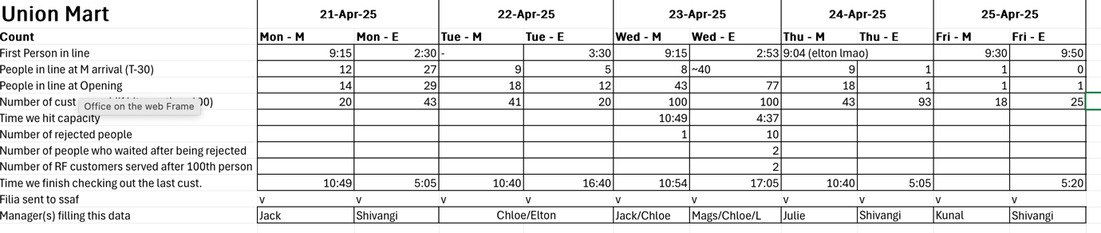
Figure 5: Mid Semester Break Data for Union Mart
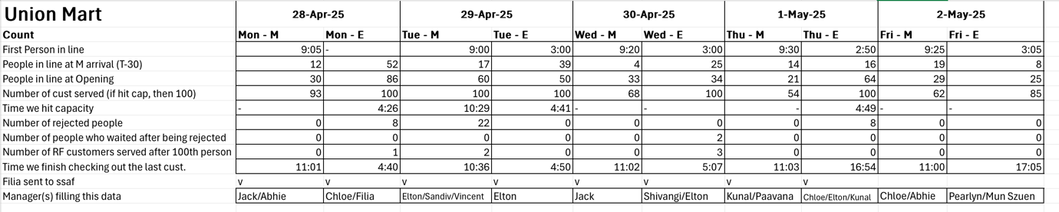
Figure 6: Week 8 Data for Union Mart
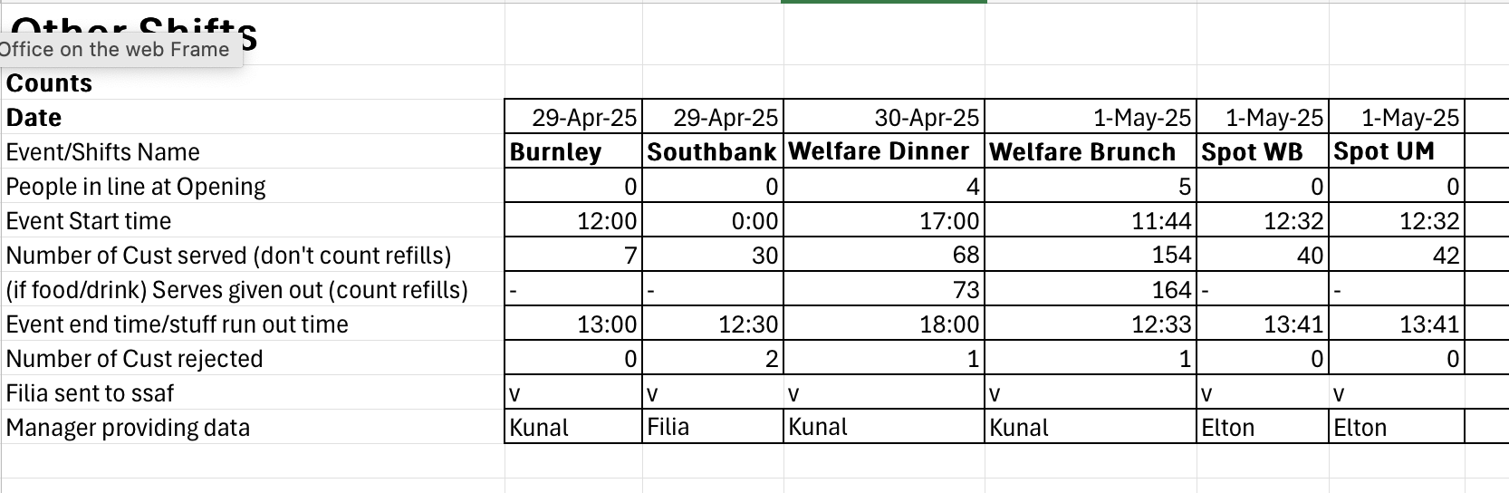
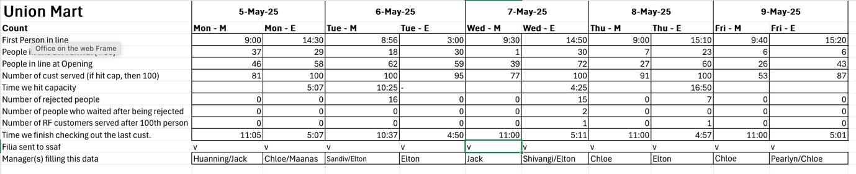
Figure 7: Week 8 Data for other UMSU Welfare Programmes
Figure 8: Week 9 Data for Union Mart
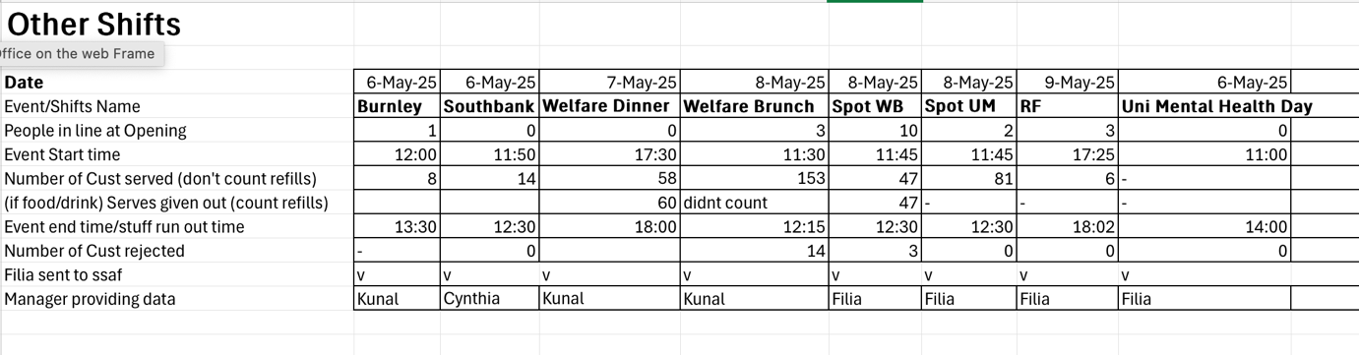
Figure 9: Week 9 Data for other UMSU Welfare Programmes and/or events

On this note, I would like to thank all UMSU Welfare volunteers for their support in making such a huge impact on the student community.

- Ran Welfare Brunch and Dinner throughout the weeks. We realised that now that we have an extra hour, thanks to Daylight Savings, the sun sets earlier and it gets colder, so we now need to move Welfare Dinner to an earlier time. We also ran Pop-ups at the Spot to provide support to students who are not able to come to the Student Precinct throughout their day at the University.
- We have released forms for Diaper Reservation to provide support to students who are also parents to manage cost cutting. For the purposes of multiplexing and getting the accurate quantity of diapers and therefore, for using the budget effectively, we have released reservations because this is a rather nice, yet important, requirement for the students.
- We also released a Microsoft form for tracking the demand for more spots in ‘Get Certified’ Short Courses, including Barista Training, RSA Certifications, First Aid, etc. to allow for effective budgeting and planning. This was done in collaboration with UMSU Women’s and UMSU International.
- The University recently released the Annual Report on Racism 2024. I briefly discussed this with Viraj and Joshua and in agreement with Joshua’s Report for Students’ Council 6 (25), one of the reviews I have so far is the lack of sufficient data, both in terms of reporting, and collection and consolidation of the data because one of the reasons they give for less data is that there were more reports but they were not part of the centralised system, so they could not consolidate and compile it properly. The Racism Survey and Report worked on and prepared by the UMSU People of Colour Department is backed by a lot more data than that by the University. The 2023 Racism Report run by UMSU People of Colour department received 855 reports, which is over 1200% of the data records used by the University. I would also like to appreciate the fact that the University has started to put some effort into the Anti-Racism Action Plan finally. UMSU Welfare will be working with UMSU President, UMSU People of Colour and UMSU Education on this.
- The Welfare Newsletter had its first edition of the year, the April Edition, released. It was a great work by the Welfare Newsletter team, being led by Alouise Thompson. There are poems, a cute comic with an easy recipe being prepared by Welfie, the UMSU Welfare mascot. I promise that it was not AI generate, but digitally hand-drawn by one of our volunteers. The edition also has a section for Affordable Local Eats and a section called ‘Student Says’ which takes responses from students through the UMSU Welfare Instagram stories. These questions can range from feedback to ideas to fun stuff like what they do to destress. The team has already prepared the May Edition, which will be going out, potentially, on Wednesday, 14 May 2025. It is a digital copy, so you can easily subscribe to receive a digital copy using your email. The link to subscribe is here.
- We have also started the planning for Stress Less Week in Week 12 with the Events team. We have reached out to UMSU Activities, UMSU Creative Arts and UMSU Environment for collaborations. We will be reaching out to a few more clubs to collaborate and show their presence at Stress Less Week.
- We were also present at the Uni Mental Health Day on Tuesday of Week 9, which was on 6 May 2025. This was being led by Filia and we borrowed a bunch of board games from UMSU Activities. There was also raffle for a small Welfie plushie.
- We also run Volunteer Catchups, a great way to connect with other volunteers, make new friends have some fun on Fridays. Reminds me of elementary school, the Friday before a break, when we would spend most of our time, just playing board games.
- Organise Welfare Department Meeting 7 (25) for May 2025.
- Attended Student Scam Working Group Meeting being organised by Tim Brabazon. I have also reached out to the UMSU Education Office Bearers to see if they have any important points for me to raise or keep in mind.

    - Actions to be completed by next report:

- Publish May Edition of Welfare Newsletter.
- Plan out and execute Stress Less Week.
- Run Union Mart and Welfare Brunch.
- Work with UMSU President, UMSU People of Colour and UMSU Education to prepare a written response to the Annual Report on Racism 2024.
- UMSU People of Colour sent through a first draft for the Racism Report for proofreading. We will provide them any support they want from us.

    - Monies approved for expenditure since last report:
- Requested Luv to pass $10,000 for Union Mart operations through Operation Subcommittee. The Welfare Committee has already this fund for Operation Subcommittee in the Welfare Department Meeting 4 (25).

    - Expenditure made since last report:

GoGet - 7th April | 58.68
GoGet - 14th April | 50.18
GoGet - 23rd April | 15.37
GoGet - 30th April | 42.24

Cheaper Buy Miles Run (Virtual Credit Card) | 113
Give A Fork - Vegan Chicken Nuggets | 1080
Coles Order Week 7 | 1660.00
Cheaper Buy Miles Week 7 | 214.80
Aldi Week 7 - Pasta Restock | 90.20
Myki Recharge | 50
IGA Order 1 | 4638.80
Myki Money (New Card for Burnley) | 36.00
Coles Order Week 9 Delivery | 2,284.20
IGA Order Soy Milk | 1200.00
Foodbank Victora | 465.94
Foodbank Victoria | 929.48
Foodbank Victoria | 549.91

    - Report on conferences attended within capacity as Office Bearer since last report:
N/A

Told the committee member of umsu welfare getting 20,000 dollars from SSAF grant
Motion: To accept the Office Bearer reports en bloc.

Mover: Kunal Dewani Seconder: Vinayak

Carried without Dissent
- Motions on Notice
Procedural motion moved to accept motions 7.1-7.6 en bloc
Mover: Vinayak Kapoor Seconder: Leon
Carried

Motion: To reimburse Alouise Thomson to account 063-238 11300425 the amount of $20 for Canva Premium Subscription from the ‘General’ Tag of ‘Event’ budget line (03-60-630-3840). (See file named ‘Invoice 1’)

Mover: Seconder:

Motion: To reimburse Filia Cahyadi to account 063-014 11011176 the amount of $20 for Myki recharge from the ‘General’ Tag of ‘Events’ budget line (03-60-630-3840). (See file named ‘Invoice 2’)

Mover: Seconder:

Motion: To allocate $1,500 for GoGet rentals from the ‘General’ Tag of ‘Events’ budget line (03-60-630-3840).

Mover: Seconder:

Motion: To allocate $30,000 for Union Mart related expenses from the ‘General’ Tag of ‘Events’ budget line (03-60-630-3840).

Mover: Seconder:

Motion: To allocate $5000 for Stress Less Week from the ‘General’ Tag of ‘Events’ budget line (03-60-630-3840).

Mover: Seconder:

Motion: To allocate $15000 for Welfare Brunch and Dinner from the ‘General’ Tag of ‘Events’ budget line (03-60-630-3840).

Mover: Seconder:

- Other Business (Motions without Notice)
- Next Meeting
  - Tentatively, 3rd Monday of June. Invite and Notice will be sent out.
- Close
Closed at 6.47pm

