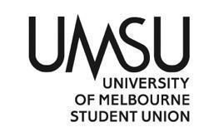
University of Melbourne Student Union
Meeting of the Students’ Council
OpSub Agenda
Meeting 5(24), Apr 22, 11:50AM
Location: Zoom

Quorum at 11:55AM
- Procedural Matters
  - Election of Chair
    - Kevin Li moved to be elected chair
    - CWD
  - Acknowledgement of Indigenous Custodians
  - Attendance
    - Mehul
    - Anndrya
    - Kunal
    - Clement (at 11:56)
  - Apologies
  - Membership
  - Adoption of Agenda
    - Moved by Chair
    - CWD
- Confirmation of Previous Minutes
    - Moved by Chair
    - CWD
- Conflicts of Interest Declaration
- Matters Arising from the Minutes
- Correspondence
- Operational Business
- Motions on Notice
Motion: That 5000$ be passed from the Whole of Union budget line as foreshadowed for the Eid event. Which will be a collaboration between POC and the Islamic Society, also with help from Activities.
Moved: Anndrya | Seconded: Kunal
CWD
- Motions without Notice
- Other Business
- Next Meeting (TBD)
- Close
  - 11:57

